s

**Global Food Production Trends and Analysis:**

**A Comprehensive Study from 1961 to 2023 Using Power BI**

**Introduction:**

ABC Company undertook a comprehensive study of global food production trends from 1961 to

2023, leveraging Power BI for insightful visualizations. The analysis encompassed key

agricultural commodities, revealing that total rice production amounted to 269 billion tonnes,

while wheat production reached 282 billion tonnes. The study highlighted that tea production

stood at 2 billion tonnes, with Africa emerging as the leading producer of green coffee.

Additionally, the research underscored a steady rise in wheat, maize, and rice production over

the years, with wheat showing the most significant increase.

The project also explored the production volumes of apples, avocados, bananas, and oranges by

different regions, identifying Europe and Asia as significant contributors. Maize production

demonstrated consistent growth, particularly from the late 1980s onward. The study further

indicated that grapes had the highest total production among fruits at 43 billion tonnes,

followed by apples, bananas, and oranges. This comprehensive analysis equips ABC Company

with valuable insights to better understand global food production trends, aiding strategic

decision-making in the agricultural sector.

**Scenario 1: Sum of Rice Production (tonnes)**

This section prominently displays the total global rice production, amounting to 269 billion

tonnes over the period from 1961 to 2023. It highlights the significant volume of rice produced,

emphasizing its importance as a staple food crop worldwide.

**Scenario 2:Sum of Wheat Production (tonnes)**

Highlighting the global wheat production, this section shows a total of 282 billion tonnes

produced between 1961 and 2023. This underscores wheat's crucial role in global food security

and its widespread cultivation.

**Scenario 3: Sum of Tea Production (tonnes)**

This section shows a gauge chart illustrating the total tea production, amounting to 2 billion

tonnes. The visual emphasizes the scale of tea production compared to other major crops.

**Scenario 4:Sum of Coffee, Green Production (tonnes) by Entity**

A bar chart depicting the distribution of green coffee production among various entities. Africa,

Asia, and America are leading producers, reflecting regional contributions to global coffee

Supply.

**Scenario 5: Sum of Wheat, Maize, and Rice Production (tonnes) by Year**

An area chart showing the annual production trends of wheat, maize, and rice from 1961 to

2023. It highlights the growth trajectories and fluctuations of these essential crops over the

years.

**Scenario 6**: **Sum of Apples, Avocados, Bananas, and Oranges Production (tonnes) by**

**Entity**

This stacked bar chart illustrates the production volumes of apples, avocados, bananas, and

oranges by different entities. It highlights the diverse contributions to global fruit production.

**Scenario 7:Sum of Maize Production (tonnes) by Year**

A donut chart depicting the yearly maize production distribution across different years. It

shows how maize production has evolved, with specific years highlighted for their significant

contributions.

**Scenario 8: Sum of Grapes, Apples, Bananas, and Oranges Production (tonnes)**

This bar chart compares the total production volumes of grapes (43 billion tonnes), apples (39

billion tonnes), bananas (32 billion tonnes), and oranges (26 billion tonnes). It provides a

comparative view of the global production scales of these popular fruits.

**Technical Architecture:**

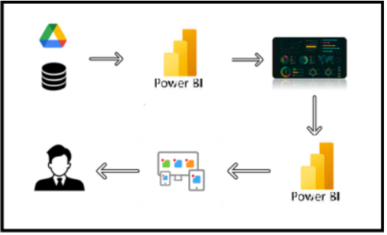

**Project Flow**

To accomplish this, we have to complete all the activities listed below,

● Data Collection

o Collect the dataset,

o Connect Data with Power BI

● Data Preparation

o Prepare the Data for Visualization

● Data Visualizations

o Visualizations

● Dashboard

o Responsive and Design of Dashboard

● Report

o Report Creation

● Performance Testing

o Utilization of Data Filters

o No. of Calculation fields

o No. of Visualizations/Graphs

● Project Demonstration & Documentation

o Record explanation Video for project end to end solution

o Project Documentation-Step by step project development procedure

**Milestone 1: Data Collection & Extraction from Database**

Data collection is the process of gathering and measuring information on variables of

interest, in an established systematic fashion that enables one to answer stated

research questions, test hypotheses, evaluate outcomes and generate insights from the

data.

**Activity 1: Downloading the dataset**

**Dataset :**

[**https://www.kaggle.com/datasets/rafsunahmad/world-food-production**](https://www.kaggle.com/datasets/rafsunahmad/world-food-production)

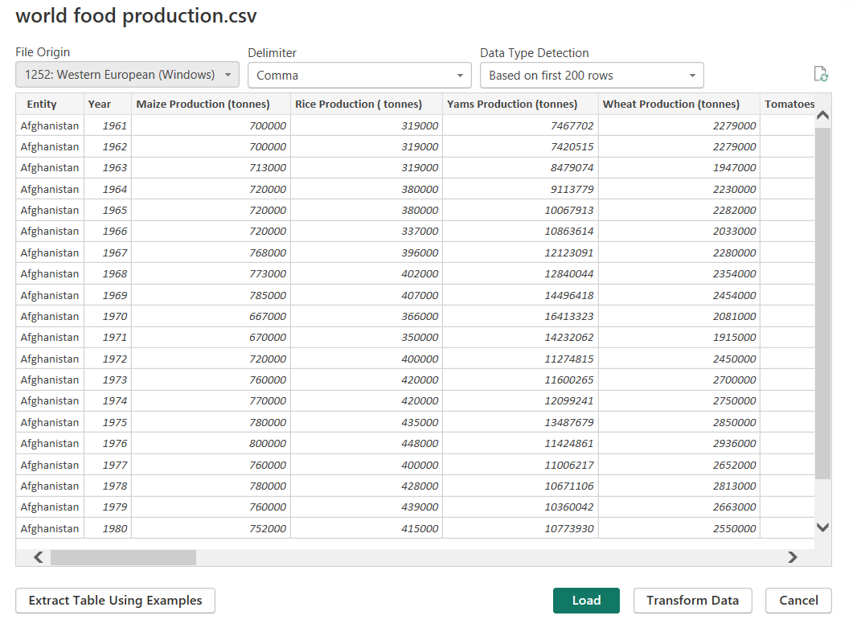

**Fig 1.1: World Food Production (CSV File)**

**Activity 1.1: Understand the data**

Data contains all the meta information regarding the columns described

in the CSV files

**Column Description of the Dataset:**

**● Entity:** Represents the country or region where the food

production data is recorded.

● **Code:** A unique identifier or code for each entity (country or

region).

**● Year:** The specific year for which the data is recorded, ranging

from 1961 to 2023**.**

● **Apples_Production (tonnes):** The total annual production of

apples measured in tonnes.

● **Avocados_Production (tonnes):** The total annual production

of avocados measured in tonnes.

● **Bananas_Production (tonnes):** The total annual production

of bananas measured in tonnes.

● **Coffee_green_Production (tonnes):** The total annual

production of green coffee measured in tonnes.

● **Grapes_Production (tonnes):** The total annual production of

grapes measured in tonnes.

● **Maize_Production (tonnes):** The total annual production of

maize measured in tonnes.

● **Oranges_Production (tonnes):** The total annual production

of oranges measured in tonnes.

● **Rice_Production (tonnes):** The total annual production of

rice measured in tonnes.

● **Tea_Production (tonnes):** The total annual production of tea

measured in tonnes.

● **Wheat_Production (tonnes):** The total annual production of

wheat measured in tonnes.

**Milestone 2: Data Preparation**

**Activity 1: Prepare the Data for Visualization**

Preparing the data for visualization involves cleaning the data to remove

irrelevant or missing data, transforming the data into a format that can be

easily visualized, exploring the data to identify patterns and trends, filtering the

data to focus on specific subsets of data, preparing the data for visualization

software, and ensuring the data is accurate and complete. This process helps to

make the data easily understandable and ready for creating visualizations to

gain insights into the performance and efficiency. Since the data is already

cleaned, we can move to visualization.

**Data Loading**

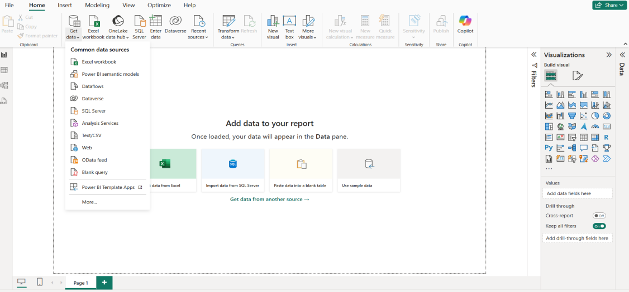

**Fig 1.1: Loading Data by selecting Get Data**



**Fig 1.2: World Food Production CSV File**

**World Food Production**

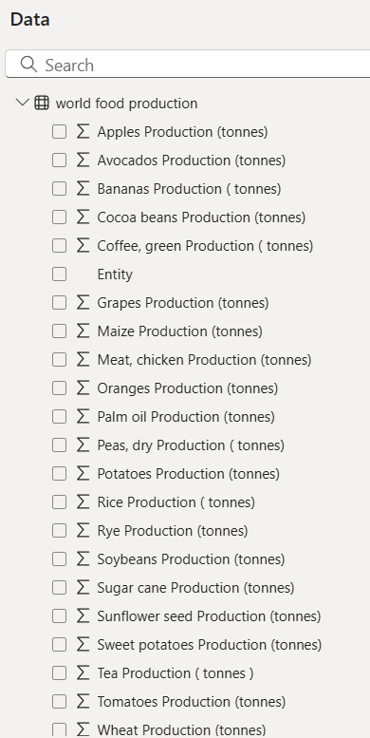

**Fig 1.3: The Data in tonnes**

**Data Cleaning**

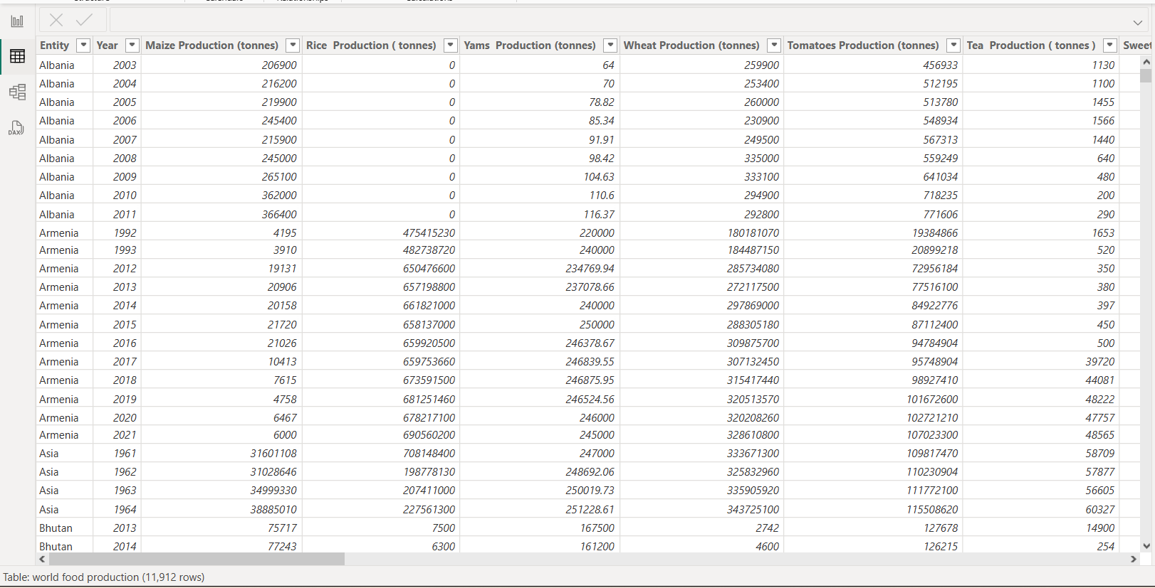

**Fig 1.4: The column containing zero values**

**Cleaning by deleting the zero values**

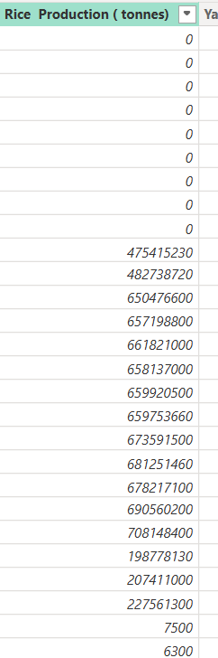 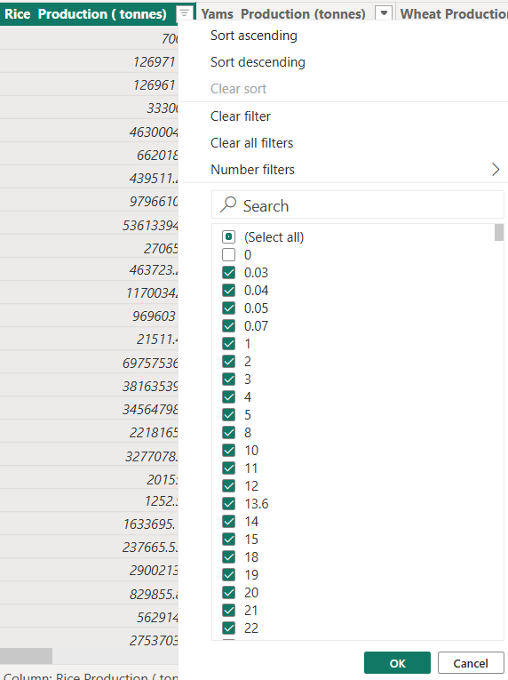

**Fig 1.5: Zero values in Rice Fig:1.6: Deselecting the zero values**

**Production (tonnes)**

**After cleaning the data by removing zero values**

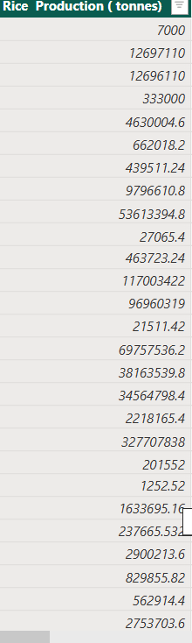

**Fig: 1.7: Values without zeros**

**Converting the Decimal values to Whole numbers because we are using the data in tonnes**

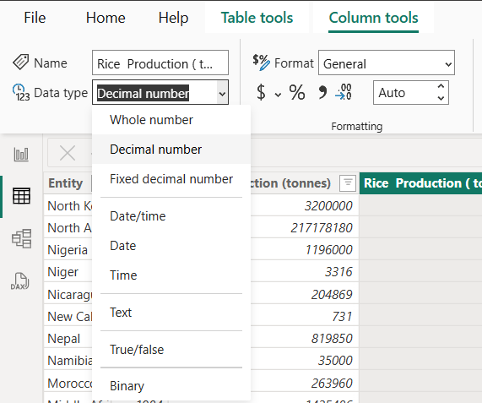 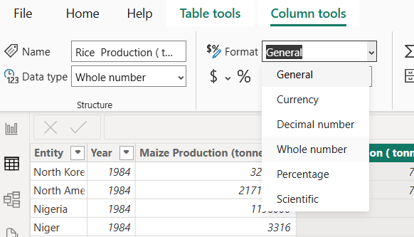

**Fig 1.8: Selecting Decimal number and General to convert into Whole numbers**

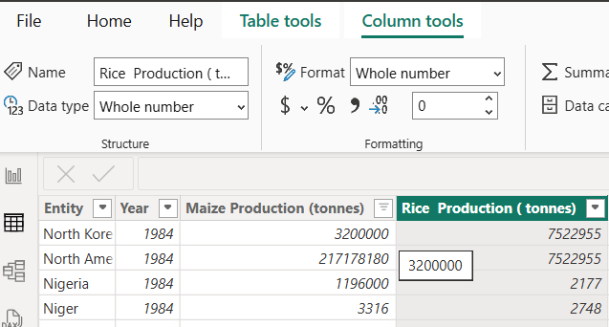

**Fig 1.9: After conversion of Whole numbers**

**Milestone 3: Data Visualization**

Data visualization is the process of creating graphical representations of data to help

people understand and explore the information. The goal of data visualization is to

make complex data sets more accessible, intuitive, and easier to interpret. By using

visual elements such as charts, graphs, and maps, data visualizations can help people

quickly identify patterns, trends, and outliers in the data.

**Activity 1: World Food Production(1961-2023)**

**Activity 1.1:The total Rice Production (tonnes)**

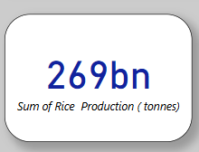

**Activity 1.2:The total Wheat Productions (tonnes)**

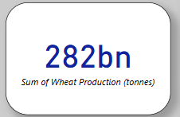

**Activity 1.3:The total Tea Production (tonnes)**

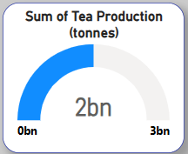

**Activity 1.4: The Sum of Coffee,green Production (tonnes) by Entity**

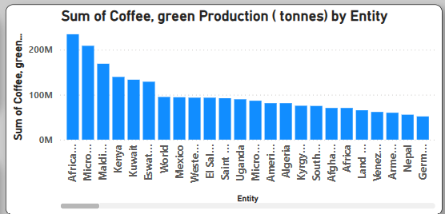

**Activity 1.5: The Sum of Wheat Production (tonnes),Sum of Maize Production (tonnes), and Sum of Rice Production (tonnes), by year**

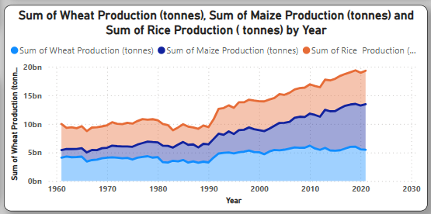

**Activity 1.6:The Sum of Apples Production (tonnes),Sum of Bananas Production (tonnes), Sum of Oranges Production (tonnes), Sum of Avocados Production (tonnes)and by Entity**

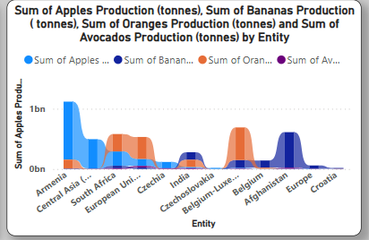

**Activity 1.7: The Sum of Maize Production (tonnes) by Year**

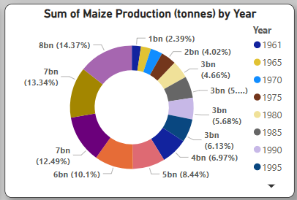

**Activity 1.8: The Sum of Grapes, Apples, Bananas, Oranges, Coffee, Avocado Productions (tonnes)**

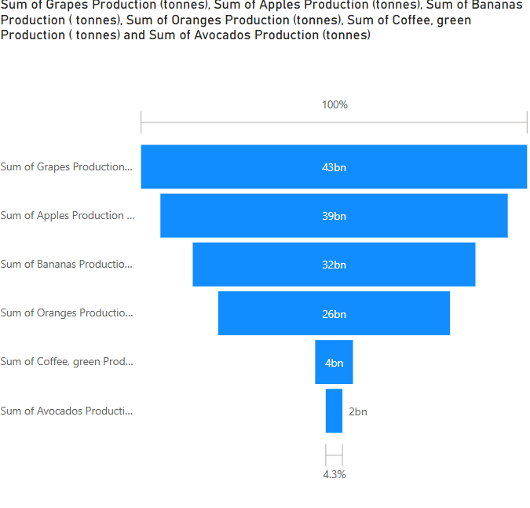

**Milestone 4: Dashboard**

A dashboard is a graphical user interface (GUI) that displays information and data in

an organized, easy-to-read format. Dashboards are often used to provide real-time

monitoring and analysis of data and are typically designed for a specific purpose or

use case. Dashboards can be used in a variety of settings, such as business, finance,

manufacturing, healthcare, and many other industries. They can be used to track key

performance indicators (KPIs), monitor performance metrics, and display data in the

form of charts, graphs, and tables.

**Activity 1:Responsive and Design of Dashboard**

**Dashboard**

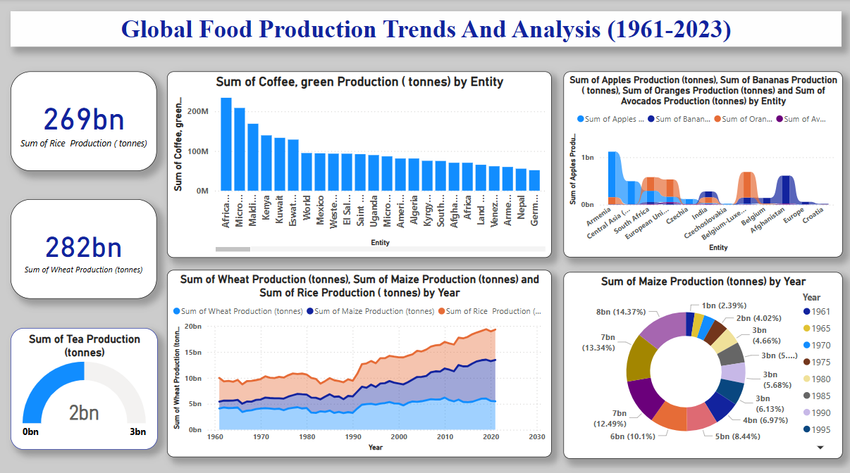

**Milestone 5: Report**

A report is a comprehensive document that provides a detailed and structured

account of data analysis, findings, and insights. It is typically used for in-depth analysis,

documentation, and communication of results. Reports are suitable for a diverse

audience, including decision-makers, analysts, and stakeholders who need a

comprehensive understanding of the data.

**Activity 1: Design of Report**

Designing a report in Power BI involves connecting to data sources, creating

visualizations like charts and graphs, customizing their appearance and

interactivity, organizing them logically on the canvas, formatting elements for

consistency and clarity, and optionally creating dashboards for a summarized

view. Throughout the process, it's essential to consider the audience's needs

and ensure the report effectively communicates insights from the data. Finally,

iterate based on feedback to continually improve the report's design and

usefulness.

**Report**

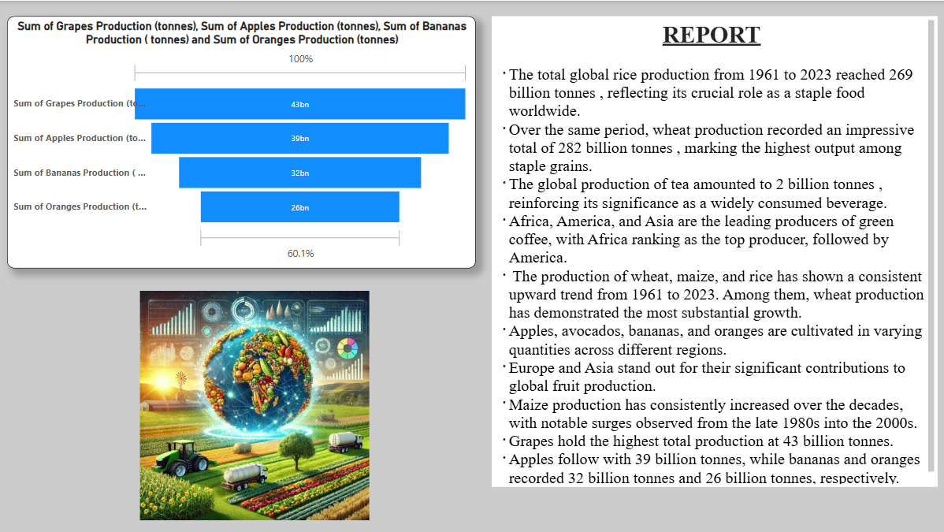

**Milestone 6: Performance Testing**

**Activity 1: Amount of Data Loaded**

"Amount of Data Loaded" refers to the quantity or volume of data that has been

imported, retrieved, or loaded into a system, software application, database, or

any other data storage or processing environment. It's a measure of how much

data has been successfully processed and made available for analysis,

manipulation, or use within the system.

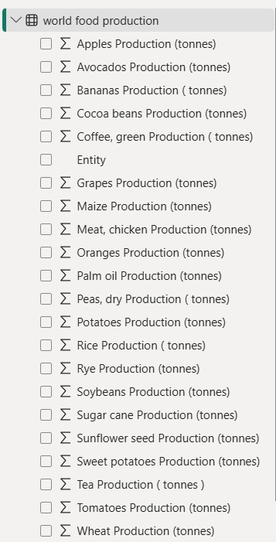

**Activity 2: Utilization of Filters**

"Utilization of Filters" refers to the application or use of filters within a system,

software application, or data processing pipeline to selectively extract,

manipulate, or analyze data based on specified criteria or conditions.

**Activity 2.1: Selected “Entity” as Filter**

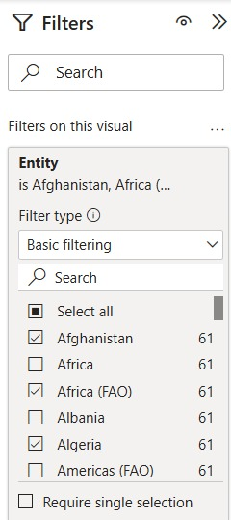 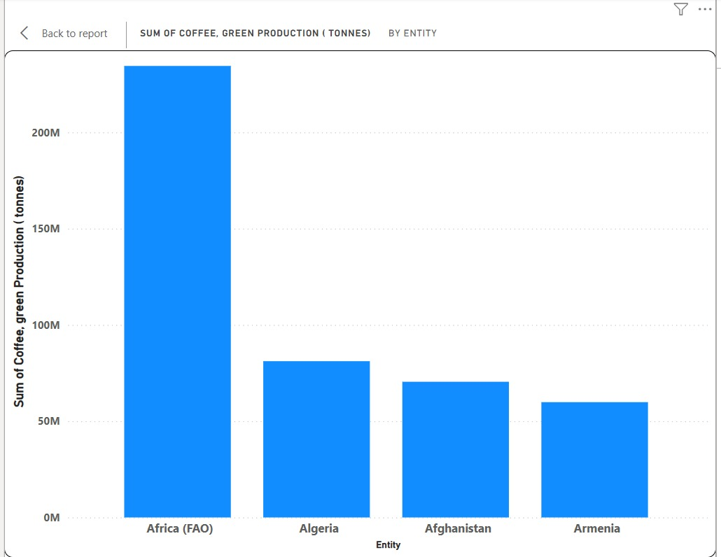

**Activity 2.2: Selected “Entity” as Filter**

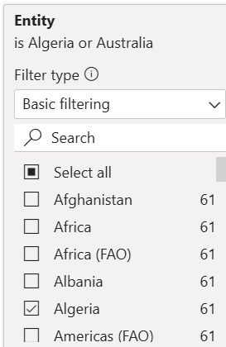 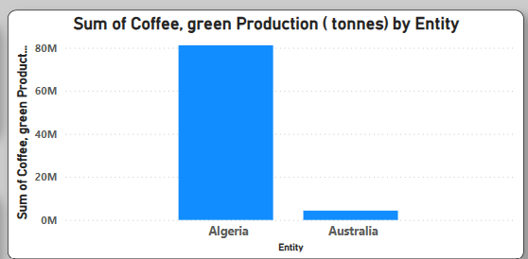

**Activity 2.2: No of Visualizations/ Graphs**

* The total Oranges Production (tonnes)
* The total Sugar Cane Productions (tonnes)
* The total Soybeans Production (tonnes)
* The total Palm Oil Production (tonnes) by Entity
* The total Grapes Production (tonnes) by Entity
* The total Meat,Chicken Production (tonnes) by Year
* The total Maize Production (tonnes) by Year
* The total Peas, dry Production (tonnes)
* The total Rice Production (tonnes) by Entity
* The total of Grapes, Apples, Bananas, Oranges, Coffee, Avocado Productions (tonnes)

**Milestone 7:Project Demonstration & Documentation**

<https://drive.google.com/drive/folders/1K4wq8EJ3z9LDkvRA_4aVroaXdNNsHuVK?usp=sharing>